

Chapter 7

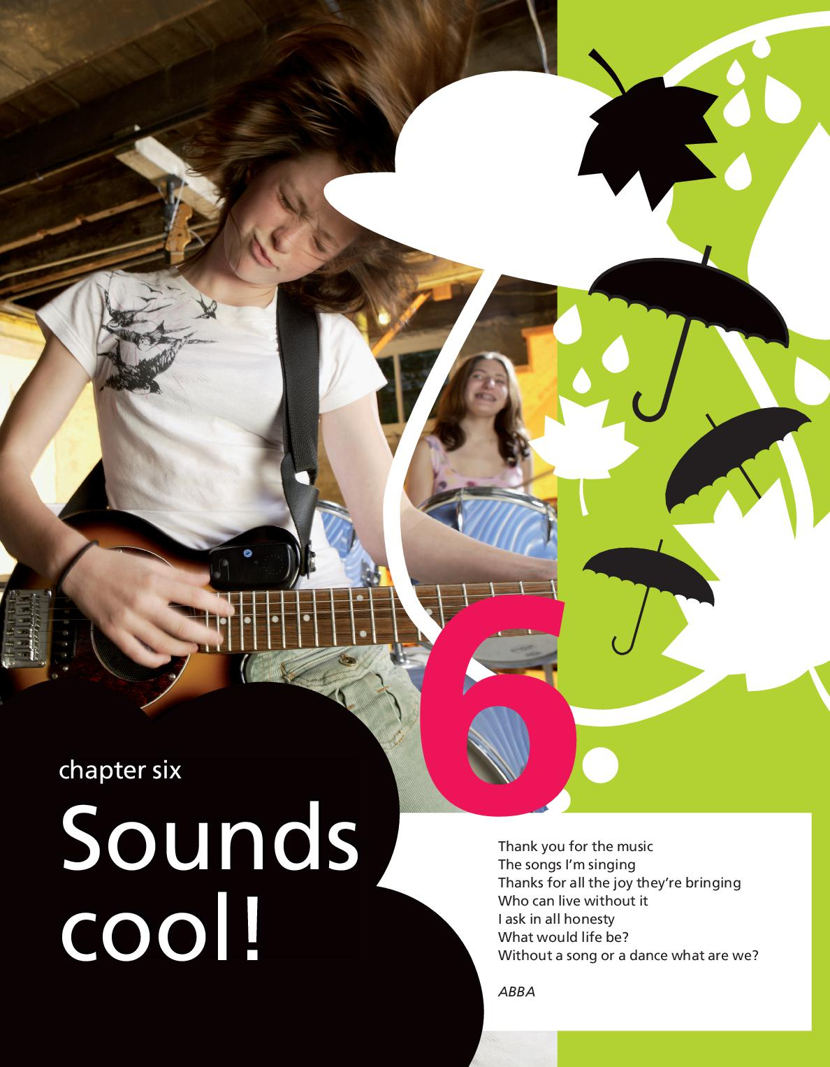

Grammar Trainer
Klas 2KGT

Plurals – Meervouden

1. Write down ◊
Schrijf de meervoudsvormen op.

- one bag two
- a sea two
- a car three
- a sausage three
- one plane six
- a loaf six
- a hobby two
- one potato a bag of
- one tattoo an arm full of
- one tomato a pound of

2. Write down ◊
Schrijf de meervoudsvormen op.

- a boy two
- a ball three
- a day four
- a bus five
- one wolf six
- one pear seven
- a box eight
- one muffin nine
- one baby ten
- one glass eleven

3. Fill in ◊◊
Fill in
Vul de juiste meervoudsvormen in van de woorden tussen haakjes.

- I like chips, but I don’t like boiled (potato) __________.
- That man has got three (wife) __________.
- Peter and I have been (friend) __________ ever since we were five years old.
- My father hasn’t got any (hobby) __________.
- Can you go to the supermarket and get me some (sausage) __________?
- There are a lot of (glass) __________ on the table.
- Eric’s little brother has got three (radio) __________.
- One pound of (tomato) __________, please.

4. Fill in ◊◊
Fill in
Schrijf de meervoudsvormen op van de woorden tussen haakjes.

I have a lot of [1]__________ (hobby), but my favourite one is eating. Every day I eat eight[2]__________ (sausage), three [3]__________ (loaf of bread), two [4]__________ (pound of tomato), ten [5]__________ (egg) and three [6]__________ (bag of potato). I drink six [7]__________ (glass of milk) and two [8]__________ (bottle of orange juice). One day I’m going to be a sumo wrestler!

5. Correct the mistakes ◊◊◊
Correct the mistakes
Read the conversation. Find the 8 mistakes and correct them.

Tim: Hi Jane!
Jane: Hi Tim, what have you got there?
Tim: Oh, just some photo’s.
Jane: Are they yours?
Tim: Yes, they are from last year’s schooltrip to the Netherlands. We went to two big city, Amsterdam and Rotterdam.
Jane: How long did you stay there?
Tim: Oh, just four day’s.
Jane: That’s short.What did you do?
Tim: My friendes and I went shopping in Amsterdam.
Jane: What did you buy?
Tim: Well, nothing actually.
Jane: What else did you do in Amsterdam?
Tim: Well, we saw a lot of old building and we took part in a lot of activitys.

Some, any, no & coumpound words – Some, any, no en samenstellingen

1. Fill in ◊
Vul in: some of any.

> Look, I’ve got [1]__________ cookery books from the library. I want to make an apple pie and maybe bake [2]__________ cookies.
< Would you like [3]__________ help with it?
> You may help me bake an apple pie. Let’s see…we need [4]__________ apples.
< Here are the apples.What else?
> Have we got [5]__________ sugar?
< Yes, here it is. And [6]__________ flour, too. But I don’t think we’ve got [7]__________ butter left.
> There is [8]__________ in the fridge. Do we have [9]__________ salt?
< Salt? Why do you need salt?
> You always put [10]__________ salt in a pie.
< Ooh, I don’t think I want [11]__________ of this pie!

2. Fill in ◊
Vul in: some of any.

> Hello, sir. I am going to give a presentation about sports. Do you have [1]__________ books about athletes?
< Yes, I have [2]__________ books about athletes and [3]__________ books about games like football, basketball and cricket.
> Oh, that’s fine! But don’t you have [4]__________ about the Olympic Games?
< No, I don’t have [5]__________ books about the Olympic Games, but I do have [6]__________ books about the World Cup Football.
> I’m sorry but I don’t need [7]__________ books on the World Cup, I only need [8]__________ books on athletics, because my presentation is about individual sports.
< Well, I’m very sorry, but I don’t have [9]__________ books on individual sports. But hold on, I do have [10]__________ books about tennis and boxing. Does that help you?
> No, not really. Oh, this is bad; if I can’t find [11]__________ books I can’t give my presentation. And tomorrow is the big day!

3. Fill in ◊◊
Fill in.
Vul bij elke zin één van de volgende woorden in.
Kies uit: any – some – no – anything – something – nothing – anybody – somebody – nobody – anywhere – somewhere – nowhere.

- I think I’ve lost my keys. I can’t find them []__________
- That sounded like the doorbell. Was there []__________ at the door?
- My father still has []__________ guilders.
- You never buy me []__________ nice for my birthday.
- There is []__________ reason to get so upset.
- Would you like []__________ sweets?
- These refugees haven’t got []__________ schoolbooks.
- I’d like to buy []__________ Christmas presents for them.
- Timothy did it all by himself, without []__________ help from others.
- Does []__________ know the answer to this question?

4. Fill in ◊◊
Fill in
Vul in: some – something – somebody – someone – somewhere – any – anything –
anybody – anyone – anywhere.

Brad: Is [1]__________ the matter? You look so tense.
Janice: I’m in a hurry and I can’t find my bicycle key [2]__________
Brad: I haven’t seen it, but it must be [3]__________ in the house. You used it yesterday evening.
Janice: I know, but I’m meeting [4]__________ in an hour and I have to leave now. And I need to go by bike, so I need my key.
Brad: You can have my bike. I’ll find your key today. I’ve never known [5]__________ who is so forgetful. Don’t forget where you leave my bike!
Janice: Don’t tease me, Brad. I’d like you to say [6]__________ nice to me for a change.
Brad: I like teasing you, little sister. I wouldn’t like to tease [7]__________ else. I like the way you get mad at me when I tease you.
Janice: Stop it and give me your key, so I can go. Please, Brad.
Brad: Here is my key, and [8]__________ apples for the trip. I know how hungry you can be after a meeting.
Janice: Thanks, can I take [9]__________ back for you from the shops on my way home?
Brad: [10]__________ car magazines, please.
Janice: [11]__________ title in particular?
Brad: No, any will do. Bye.

5. Cross out ◊◊◊
Choose the correct alternative
Read the conversation and choose the correct missing word.

Barbara: Jamie, is there [1] some / any milk left? I can’t find it [2] somewhere / anywhere.
Jamie: Yes, there is [3] some / any in the bottle on the table.
Barbara: Thanks. Would you like [4] some / any milk?
Jamie: No, thank you. I don’t think I’ll drink [5] some / any tonight. Could I have [6] some / any water instead, please?
Barbara: Sure. I believe there is [7] some / any very cold water in the fridge.
Jamie: Would you like [8] some / any cookies as well?
Barbara: Yes, please. But are there [9] some / any left? The jar looks empty.
Jamie: Really? Then my greedy brother must have eaten all of them.
Barbara: Never mind. Weren’t you talking about a Chinese classmate the other day?
Jamie: Yes, there is [10] someone / anyone in my class from China. She has been here for quite [11] some / any time now. Why do want to know that?
Barbara: I was wondering if you could ask her [12] some / any questions for me.
Jamie: No problem. Is there [13] something / anything special you want me
to ask?
Barbara: No, I don’t have [14] something / anything particular in mind. Maybe you could ask her [15] some / any questions about life in China. I’m writing a paper about China. But I don’t know [16] something / anything about this country. I’ve been looking for information on the Internet, but that’s not enough. I’ll write down [17] some / any questions for you, so you can ask her [18] some / any tomorrow. Is that all right?
Jamie: I would be happy to do that for you. No problem!

6. right/wrong? ◊◊◊
Choose the correct alternative.
Read the sentences. Indicate whether the sentence is correct or incorrect. Underline the faulty word and correct the sentence.

- The bell is ringing. There must be someone at the door. right / wrong
- I can’t find my shirt somewhere. Have you seen it? right / wrong
- Anybody drove Tom to the station this morning. right / wrong
- If the conductor doesn’t know, we could ask someone else. right / wrong
- I have never met somebody like you before. right / wrong
- I don’t have any change left in my purse. right / wrong
- Can I offer you anything to drink? right / wrong
- I need any new clothes. right / wrong

Much/many, little/few & (a) lot(s) of

1. Fill in ◊
Vul het juiste woord in. Kies uit: A lot of – lots of – much – many

- There are (a) __________ wild animals in Africa.
- We haven’t got (a) __________ food left.
- There weren’t (a) __________ children at the party.
- There’s (a) __________ lemonade in the fridge, but we haven’t got cola.
- I didn’t see (a) __________ of my friends yesterday.
- How (a) __________ DVDs have you got?
- Did you get (a) __________ cards for your birthday?
- They got (a) __________ presents when they got married.
- They don’t have (a) __________ money to spend.
- We got (a) __________ emails, but we didn’t get (b) __________ phone calls.

2. Fill in ◊
Vul de open plekken in door much – many – few – a few – little – a little in te vullen.

Donny: Pete, have you got your wallet on you?
Pete: Yeah, why?
Donny: Well, I forgot mine and I need [1]__________dollars.
Pete: How [2]__________ of them do you need?
Donny: Ten will do.
Pete: I’m afraid I can’t lend you that [3]__________ money.
Donny: Ah, Pete come on. You know you’re one of the [4]__________ people I can ask.
Pete: Have you ever wondered why?
Donny: Because I haven’t got [5]__________ friends?
Pete: No, stupid. You’ve got a lot of friends. It’s just that they don’t want to lend you anything,because you never pay back what you’ve borrowed.
Donny: That’s not true. It’s just that I get very [6]__________ pocket money. So it takes me a long time before I can pay back what I owe.
Pete: For most people that takes too [7]__________ time.
Donny: That’s the trouble with people nowadays. They have so [8]__________ patience. They always need everything right away.
Pete: So do you, remember? What do you need the money for anyway?
Donny: Oh, to pay back [9]__________ debts.
Pete: I don’t think it’s a good idea to pay off your present debts by borrowing money.

4. Fill in ◊◊
Maak de zinnen compleet door het juiste woord in te vullen. Kies uit: A lot of,
lots of, much, many, little en few. Soms zij er meerdere antwoorden mogelijk.

> John, could you do me a favour?
< Euhm, I guess.What is it you want?
> Well, the problem is that I haven’t got [1]__________(veel) money, so I was hoping you could lend me some.
< Is that all? Yes, of course I can. I know what it’s like to have [2]__________ (weinig) money.
> Yes, it’s awful. There are only [3]__________ (weinig) friends who will lend you money when you really need it.
> I know. One time I asked a friend of mine and he started asking [4]__________ (veel) questions. He wanted to know what I was going to buy.
< I don’t mind telling you what I am going to buy. You see, I saw this fantastic CD player in an advertisement and I heard there are only a [5]__________ (weinig) left.
> How do you know that?
> The salesman told me. Unfortunately, he gave [6]__________ (weinig) information, so that’s all I know.
< Well, if you say there aren’t [7]__________ (veel) left, shouldn’t you hurry? They may be gone when you get there.
> Don’t worry. The salesman said he would set aside one for me. I told him I am a professional DJ and that my old CD player had broken down.
< But you’re not a DJ and you have [8]__________ (weinig) CDs!
> Yes, but he doesn’t know that! Besides, this is just a little lie. [9]__________ (veel) people lie every now and then.
< Then how do I know if you really haven’t got [10]__________ (veel) money?

5. Fill in ◊◊◊
Fill in
Vul de ontbrekende woorden in. Kies uit: a lot of – lots of – much – many – little – few.
Er zijn meerdere antwoorden mogelijk.

> Hi Ellen! What are you doing?
< I’m raising money for charity. I have already collected [1]__________ money.
> Which charity organisation are you raising money for?
< For War Child. They do [2]__________ for children who live in countries where there are wars. I gave you a leaflet the other day, remember?
> Yeah, but there wasn’t [3]__________ information in that leaflet. What exactly do they do for those children?
< Well, why don’t you visit their web site? There’s [4]__________ information about War Child on it. Do you want to give me a hand with raising money?
> Um, I’ve got [5]__________ time, you know. Always busy …
< That’s what most people say. Fortunately, there are [6]__________ people who do want to do things for charity.
> Are you sure? [7]__________ of my friends do these kind of things. Most of them think charity is boring.
< Not always. There will be a charity concert tomorrow with [8]__________ famous artists and all the money will go to War Child. I’ve been asked to help out, I’ve got to sell the tickets. The concert is very popular. I’ve only got [9]__________ tickets left.
> Will you get paid for it?
< No, but I can go to the concert for free and I’m invited to a party with all the artists. Robbie Williams will also be there.
> Um, I’ve got this great idea. I’ll change all my plans, so that I’ve got [10]__________ time for Robbie… um… charity I mean.

